Do People Prescribe Optimism, Overoptimism, or Neither?

Jane E. Miller^{1*}, Inkyung Park¹, Andrew R. Smith², and Paul D. Windschitl¹

Currently in press at Psychological Science
OSF: https://osf.io/kd6hu/

¹Department of Psychological and Brain Sciences, University of Iowa, Iowa City, IA, USA
²Department of Psychology, Appalachian State University, Boone, NC, USA

*Correspondence concerning this article should be addressed to Jane E. Miller, Department of Psychological and Brain Sciences, University of Iowa, Iowa City, IA 52242. Email: jane-miller@uiowa.edu.

This work was supported by Grant SES-1851738 to Paul Windschitl and Andrew Smith from the National Science Foundation.

Abstract
Past work has suggested that people prescribe optimism—believing it is better to be optimistic, instead of accurate or pessimistic, about uncertain future events. Here, we identified and addressed an important ambiguity about whether those findings reflect an endorsement of biased beliefs—i.e., whether people prescribe likelihood estimates that reflect overoptimism. In three studies, participants (total N = 663 U.S. university students) read scenarios about protagonists facing uncertain events with a desired outcome. Results replicated prescriptions of optimism when using the same solicitations as in past work. However, we found quite different prescriptions when using alternative solicitations that asked about potential bias in likelihood estimations and that did not involve vague terms like “optimistic.” Participants generally prescribed being optimistic, feeling optimistic, and even thinking optimistically about the events, but they did not prescribe overestimating the likelihood of those events.

Statement of Relevance

Psychological research has shown that people tend to be optimistic about uncertain, desirable events and that people think other people should be optimistic too, even when given the choice of being accurate. This is puzzling, given that accurate predictions are widely valued in science and across professional domains as an important step toward making sound decisions and policies. We suspected that people’s endorsements of optimism did not equate to endorsements of optimistically-biased estimations of likelihoods. In our studies, we determined that how you ask people about their recommended levels of optimism can have a dramatic influence on whether people seem to support having optimistically-biased expectations. We found that people do not generally recommend being overly optimistic, meaning they do not recommend that people overestimate the likelihood of desirable events. The more nuanced understanding of this issue is ultimately important for improving decisions about, and preparations for, important life events.

Keywords: optimism, estimation, bias, forecasting, prediction, accuracy, judgments

Do People Prescribe Optimism, Overoptimism, or Neither?

When it comes to predictions about the future, accuracy is widely valued by professionals and scientists (Chang, Chen, Mellers, & Tetlock, 2016; Moore et al., 2017; Soll, Milkman, & Payne, 2015; Tetlock & Gardner, 2015). For events across many domains (e.g., weather, markets, and politics), establishing well-calibrated forecasts allows for optimal planning and resource allocations. Despite the value of accuracy, one does not need to look far in the media and scientific literature to find advocates for being optimistically bent about the future (Leedham, Meyerowitz, Muirhead, & Frist, 1995; Scheier & Carver, 1993; Seligman, 2006; Willard & Gramzow, 2009).
To examine whether prescriptions of optimism are something that most people would endorse, Armor, Massey, and Sackett (2008) asked participants how protagonists in scenarios should view their chances of success for an upcoming event. The results favored prescriptions of optimism. Two direct replications have supported those findings (Open Science Collaboration, 2015; Tenney et al., 2015). Armor et al. (2008) concluded that “In contrast to…unbiased predictions, people’s prescriptions suggest that they believe optimistically biased predictions are ideal.” (p. 330). The paper is often cited as evidence that people think it is better to be optimistic than accurate or pessimistic (e.g., Hoorens et al., 2017; Shepperd, Waters, Weinstein, & Klein, 2015; Zhang & Fischbach, 2010). The present work, however, provides a crucial clarification to this conclusion by addressing whether prescribing optimism also means that people prescribe biased estimations of likelihood.
What does it mean to prescribe optimism?
For the four scenarios used in Armor et al. (2008), participants were asked, “…would it be best for [protagonist] to be optimistic or pessimistic about [the desired outcome]…” Reponses were made on scales that had extremely pessimistic and extremely optimistic as endpoint-anchor labels, with the midpoint labeled as accurate. Armor et al. (2008) also tested moderators, specifically whether the protagonist had agency over the upcoming decision, whether the decision was already made, and whether they had control over the outcome. These moderators had some influence, but the tendency to prescribe optimism was significant regardless of the moderators.
Although the findings from Armor et al. (2008) show that people value being optimistic, the meaning and limits of this conclusion require more examination. The definitions of psychological and emotion constructs can be vague, and this can be consequential for drawing conclusions from studies that rely on lay interpretations of those constructs (e.g., Barrett, 2006; Lucas, 2018; Moore & Schatz, 2017). “Optimistic” could have various interpretations. Depending on circumstances, being optimistic might refer to believing one’s chances of experiencing a desired event are above some baseline (e.g., better than 50-50 chance, better than before, or better than other people’s chances). Or, being optimistic could refer to a feeling or intuition about how an event will turn out, more so than about one’s estimate of an event’s chances (e.g., Carver, Scheier, & Segerstrom, 2010). Or, it could refer to one’s demeanor or general directional orientation (Hazlett, Molden, & Sackett, 2011; Peterson, 2000). Telling someone to be optimistic might be similar to saying “it’s a good possibility,” or “focus on the positive.”
Given the potential interpretations of the terms “optimistic” and “pessimistic,” and given Armor et al.’s (2008) reliance on those terms, we thought it was important to test prescriptions without using those particular terms. Our specific interest was in the possibility that the findings from Armor et al. did not necessarily mean that people would also prescribe being biased in overestimating likelihoods for desired outcomes. Armor et al. didn’t specifically ask how people should estimate likelihoods. In the next section, we briefly discuss how theories and prior research point in conflicting directions on whether people would prescribe such bias in likelihood estimates.
Conflicting Perspectives
One could argue that because people generally associate optimism with positive outcomes, they would endorse overestimating the likelihood of a desired outcome (i.e., misestimating in an optimistic direction). They might have some awareness that optimism can be important for motivating behavior that influences outcomes (Tenney et al., 2015; Zhang & Fishbach, 2010), and they might overgeneralize this to prescriptions about likelihood estimates—even for uncontrollable outcomes. People might also associate positive characteristics with people who are optimistic or confident (e.g., enjoying experiences more, being more socially accepted; Armor & Taylor, 2002; Helweg-Larsen et al., 2002; Klaaren, Hodges, & Wilson, 1994; Shepperd, Falkenstein, & Sweeny, 2018). They might then believe that being optimistically biased will bring about those characteristics. Finally, believing there is a high likelihood of a positive outcome might be viewed as a pleasurable anticipation (itself a source of experienced utility; Morewedge, 2015)
However, underestimation also has appeal. Defensive pessimism describes people who purposely make pessimistic predictions about performance outcomes to motivate themselves to achieve a desired outcome (Gasper, Lozinski, & LaBeau, 2009; Norem & Cantor, 1986; Shepperd et al., 2018). Pessimistic predictions can also be a way of “bracing” oneself against feeling upset or disappointed when a desirable outcome does not occur (Carroll, Sweeny, & Shepperd, 2006; Sweeny & Krizan, 2013). It is possible then, that people might recognize benefits of being pessimistic, and they might widely prescribe the underestimation of likelihoods for desired outcomes.
Of course, prescriptions of no bias are also possible if people value accuracy and objectivity, or if countervailing biases even out.
The Current Research
Our research addressed this empirical uncertainty about whether prescriptions of “optimism” also mean that people prescribe biased estimations of likelihood. In 3 preregistered studies involving the scenarios from Armor et al. (2008), we examined how altering the solicitations of prescriptions changed the level of optimism (or pessimism) that was prescribed.
Study 1 had two conditions: one that used the original prescription measure from Armor et al. and one that used a new prescription measure that focused on likelihood estimation and omitted some potentially biasing features of the original measure. The results were quite different between those conditions. In Studies 2 and 3, we varied features of the prescription measures to disambiguate which properties produced the different results. These properties and their subsequent influence on results are summarized in Table 1 and discussed in detail later. Across all studies, we also tested two of the moderators (commitment and agency of the protagonist) that were examined by Armor et al. (2008).
Table 1. Overview of studies and properties of the prescription measures used in each study.
Studies | Condition  (Prescription  Measure) | Properties of the Measures |  |  | Prescription Results (relative to scale midpoint)
 |  | Question Terms and Scale Anchors | Referred to Feelings? | Included "Best"?
Study 1 | Original Wording | Pess/Opt | ? | Yes | Above
 | Estimation Wording | Under/Over Est | No | No | Below
Study 2 | Feeling Wording | Pess/Opt | Yes | No | Above
 | Thinking Wording | Pess/Opt | No | No | Above
Study 3 | Feeling Wording | Pess/Opt | Yes | No | Above
 | Estimation Wording | Under/Over Est | No | No | Below
Note. The three columns in the middle show the potentially important features of the wording used to solicit prescriptions. Some wordings were about pessimism/optimism and some were about under/over estimation of likelihood (see “Question Terms and Scale Anchors” column). Some referred to feelings (next column). Some included words like “best” (next column). The far-right column characterizes the overall, significant findings for each wording/ condition. “Above”/“below” means the responses tended to fall significantly above/below the relevant scale’s midpoint. For example, in Study 1, this means people prescribed optimism in the original wording condition yet underestimations of likelihoods in the estimation-wording condition. In Studies 2 and 3 we varied properties of the prescription measures to disambiguate which properties account for the empirical difference in Study 1.
Study 1
Study 1 tested two types of wording for prescription measures—the original Armor et al. (2008) wording and a new wording that we will call estimation wording. The estimation wording was more narrowly focused on prescriptions for likelihood estimations and excluded some potentially biasing features of the original wording. We predicted that results for the original wording would replicate (i.e., favoring prescriptions of optimism), but the estimation wording would reveal less optimistic prescriptions.
Method
Our study was not intended to be a direct replication of Armor et al. (2008), given previous direct replications (i.e., Open Science Collaboration, 2015; Tenney et al., 2015). We made a series of changes to their original design, primarily to reduce participant fatigue. See Supplemental Online Materials-Reviewed (SOM-R) for a full overview of these changes.
Design, Participants, and Statistical Power
Aside from a counterbalancing factor, the design was a 2(Wording: original/estimation) x 3(Scenario Version) mixed design, with wording as the between-subjects factor. We preregistered a sample size of 324 participants on the Open Science Framework (link: osf.io/r2muz), which far exceeded 95% power to detect a medium-sized difference in prescriptions between the two wording conditions. The target sample size was based on the minimum sample size needed for another study in the same data collection session as this study. After completion of all posted sessions, our final sample size was 331 University of Iowa undergraduates (230 women, 100 men, 1 unreported, M_{age} = 18.75, SD = 0.96).
Scenarios and Version Descriptions
We used 3 scenarios from Armor et al. (2008), which each described a protagonist facing an event with an uncertain outcome (winning an award, having a successful surgery, experiencing a business success). Whereas Armor et al. created 8 versions for each scenario (to test moderators), we used only 3 versions of each scenario, to be described shortly. Every participant saw each of the three scenarios (for a total of three) but we counterbalanced which of the three version types went with each scenario. See Supplemental Online Material- Reviewed (SOM-R) for a full overview of each of the counterbalancing conditions.
Across all three types of versions of a scenario, the protagonist had little or no future control over how the event would turn out. The versions varied in whether a decision relevant to the event had already been made (commitment) and who did/would make that decision (agency). For example, consider the award scenario. In this scenario, the protagonist, Lisa, was notified that her paper, which could not be modified, might win an award if entered into a competition. In the Internal Agency/Pre-commitment version of this scenario, passages indicated that the decision to apply for the competition is hers and she has not yet decided. In the Internal Agency/Post-commitment version, the decision was hers and she already applied. In the External Agency/Post-commitment version, the decision was her advisor’s, who already submitted Lisa’s paper for the award.
Prescription Measures
Participants were randomly assigned to one of the two wording conditions. Half of the participants always saw prescription questions that used the original wording from Armor et al. (2008):
Under the circumstances described in this story, would it be best for [Lisa] to be optimistic or pessimistic about the likelihood of [winning the award]? In other words, what is the ideal prediction for [Lisa] to make? In the light of the situation that she is in, it would be best to be:”
The five response options had these labels: Extremely pessimistic, Moderately pessimistic, Accurate, Moderately optimistic, and Extremely optimistic. This is a small modification from the scale used in Armor et al. (2008), which was a 9-point scale. However, their scale had only five anchors, thus our scale retained the same anchor wording. The question was the same for each scenario except for the bracketed parts, which was specific to the scenario.
The other half of the participants saw prescription questions that used the new “estimation wording,” focusing more on likelihood estimates:
Under the circumstances described in this story, how should [Lisa] estimate the likelihood of [winning the award]? In other words, what way of thinking would be advisable? In light of the situation that she is in, [Lisa] should ____ her likelihood of [winning the award].
The five response options had these labels: Greatly underestimate, Slightly underestimate, Accurately estimate, Slightly overestimate, and Greatly overestimate. In addition to shifting the focus to how the protagonist should estimate the likelihood of the outcome, the new estimation wording omitted the positively-valence terms “best” and “ideal” that were in the original wording (both here and in Armor et al., 2008). We consider those to be potentially biasing features of the question—perhaps priming a positive valence or creating a misinterpretation of the question as asking for how a protagonist would feel if the protagonist’s situation was ideal.
Procedure
Participants took the study at individual computer terminals. After consenting, they first completed a different, unrelated study before reading the first scenario. Participants always saw the scenarios in a fixed order, starting with the award scenario and ending with the financial investment scenario. They were randomly assigned to answer one of the two dependent variables and answered the same one for each of the three scenarios. After completing all of the main dependent variables, participants answered 11 exploratory measures for each scenario. These exploratory measures assessed perceptions of the sensibility of different reasons for prescribing optimism/realism/pessimism. See Supplemental Online Materials-Unreviewed for the measures.
Participants then answered basic demographic questions before being debriefed for both studies and dismissed.
Results
All prescriptions were coded from -2 to +2. For both the original-wording and estimation-wording conditions, the scale midpoint is 0 and reflects a prescription of accuracy. Means above 0 would reflect optimism in both conditions. More precisely, they would reflect prescriptions of optimism in the original condition and prescriptions of overly optimistic estimations in the estimation-wording condition. Means for prescriptions across all factors can be found in Table 2. The counterbalancing factor was included in preliminary analyses but omitted here. Those results do not materially impact any conclusions reported below but see SOM-R for those analyses.

Table 2. Study 1 Mean Prescriptions Per Scenario, Version, and Prescription Wording
Scenarios | Prescription  Wording | Scenario Moderators |  |  | Average  (collapsed across versions)
 |  | Internal agency/  pre-commitment | Internal agency/  post-commitment | External agency/  post-commitment
Scenario 1  (Award) | Original Wording | 0.55 (0.87) | 0.31 (0.90) | 0.58 (0.85) | 0.48
 | Estimation Wording | -0.44 (0.72) | -0.55 (0.63) | -0.49 (0.74) | -0.49
Scenario 2 (Surgery) | Original Wording | 0.65 (0.95) | 0.67 (1.07) | 0.47 (1.14) | 0.60
 | Estimation Wording | -0.24 (0.99) | -0.04 (1.03) | 0.16 (1.07) | -0.04
Scenario 3 (Investment) | Original Wording | -0.15 (0.83) | 0.04 (1.01) | 0.21 (1.06) | 0.04
 | Estimation Wording | -0.07 (0.79) | -0.24 (0.97) | -0.19 (0.91) | -0.17
Note. Parenthetical numbers reflect standard deviations. The scale for the prescription question in the original-wording condition went from -2 (Extremely pessimistic) to +2 (Extremely optimistic), with the midpoint labeled as "Accurate". The scale in the estimation-wording condition went from -2 (Greatly underestimate) to +2 (Greatly overestimate), with the midpoint labeled as "Accurately estimate".

Prescriptions were submitted to a 2(Wording: original/estimation) x 3(Version: Internal Agency/Pre-commitment, Internal Agency/Post-commitment, External Agency/Post-commitment) repeated measures ANOVA. Figure 1 shows the pattern of results. In support of our main hypothesis, participants gave different prescriptions as a function of the prescription measure’s wording, F(1, 324) = 99.10, p < .001, η_{p}² = .234. With the original wording, participants generally prescribed optimism (M = 0.37, SD = 0.60), with a mean that was significantly above the scale midpoint of ‘accurate’, t(165) = 7.94, p < .001, d = 1.23, 95% CI [0.28, 0.47]. This replicated Armor et al. (2008). However, in the estimation-wording condition, participants generally prescribed underestimation (M = -0.23, SD = 0.48), with a mean that was significantly below the midpoint of ‘accurately estimate’, t(164) = -6.25, p < .001, d = -0.97, 95% CI [-0.31, -0.16]. In other words, participants generally prescribed a pessimistic estimation of likelihood.
A secondary interest was whether the scenario versions would influence prescriptions. Because Armor et al. (2008) found that moderators like agency and commitment influenced prescriptions, we expected that prescriptions might be different across the three version types that we used, at least in the original wording condition. However, the effect of version was not significant in the full 2(Wording) x 3(Version) ANOVA, F(2, 648) = 0.84, p = .433, η_{p}² = .003. The effect was also non-significant within just the original wording condition (p = .630). Moreover, the Wording x Version interaction was not significant, F(2, 648) = 0.005, p = .995, η_{p}² = .000.
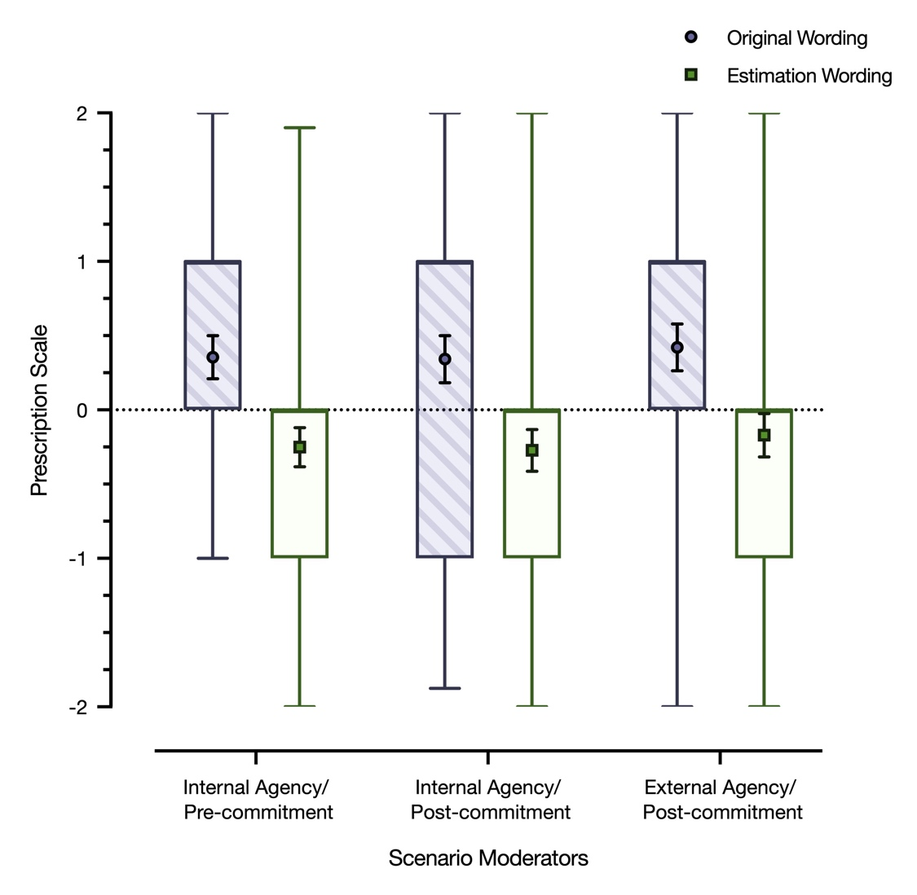
Figure 1. Study 1 mean prescriptions per scenario version and prescription wording. In each box plot, the symbol indicates the estimated mean, error bars indicate 95% confidence intervals, and the shaded box indicates the distribution of the data from the 25th to the 75th percentile.
The ANOVA reported above treated version as the repeated variable, but we can also treat scenario (i.e., award, surgery, investment) as the repeated variable. In a 2(Wording: original/estimation) x 3(Scenario) mixed ANOVA, the effect of wording was necessarily the same as already reported. The effect of scenario was significant, simply reflecting the fact that more optimism was prescribed for some scenarios/protagonists than others, F(2, 648) = 13.49, p < .001, η_{p}² = .040. A significant Wording x Scenario interaction revealed that the impact of wording varied by scenario, F(2, 648) = 14.40, p < .001, η_{p}² = .043.
Although the effect of wording varied by scenario, we note that the effects of wording were still widespread. Five of the six simple-effect tests of wording within each scenario and within each version were significant and in the same direction (ps < .05), and the sixth simple-effect test on the business investment scenario was marginally significant, p = .051. Figure 2 displays information about the proportions of participants who gave various prescriptions as a function of wording. Clearly, there are individual differences in the sorts of prescriptions people make, but it is just as clear that how one asks for a prescription has a substantial effect on answers. When asked for prescriptions using the original wording from Armor et al. (2008), the modal response was optimism (53% of responses), but when asked with the new wording that focused on likelihood estimation, the answers reflecting optimism were relatively rare (20% of responses). The answers reflected accuracy or pessimism about equally often.
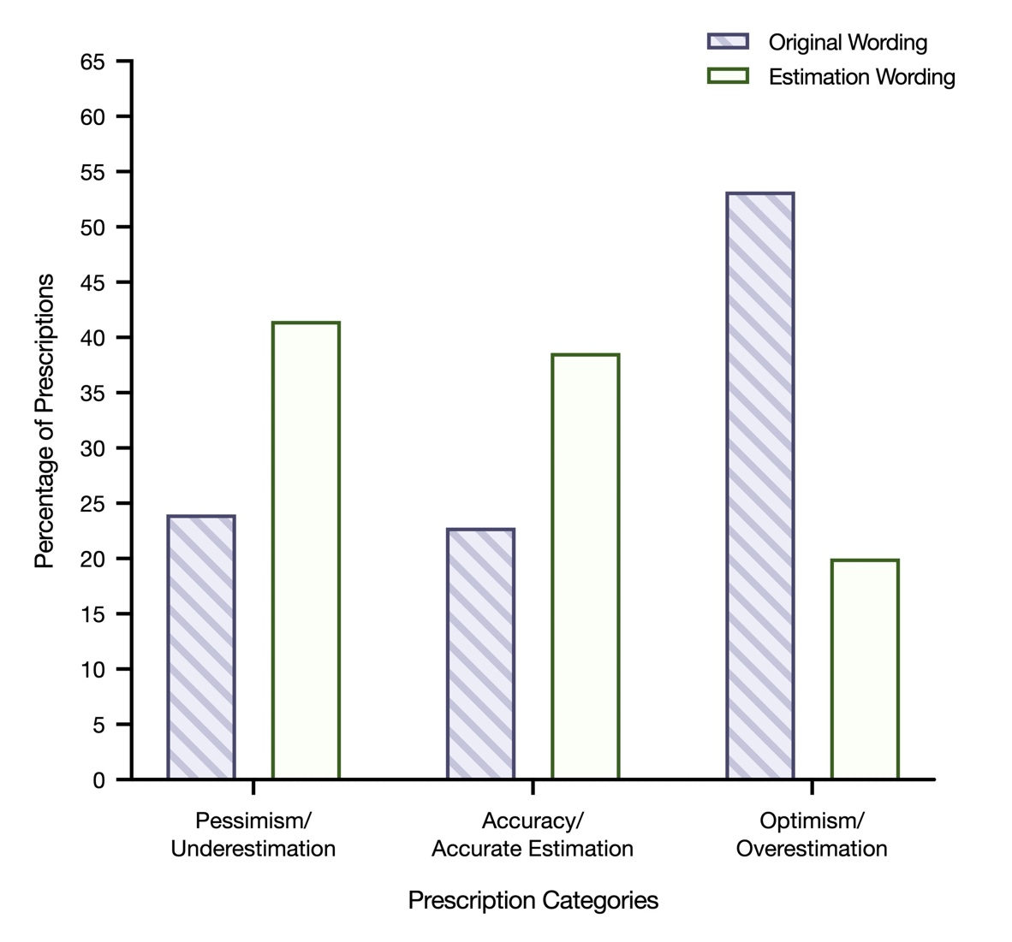
Figure 2. Proportion of prescription responses (total N of responses = 988) per prescription wording for pessimism, accuracy, and optimism. The category of pessimism/underestimation—the 2 leftmost bars—reflects responses of either a -2 (extremely pessimistic/greatly underestimate) or a -1 (moderately pessimistic/slightly underestimate). The category of optimism/overestimation—the 2 rightmost bars—reflects responses of either a +1 (moderately optimistic/slightly overestimate or +2 (extremely optimistic/greatly overestimate). The category of accuracy/accurate estimation reflects a response of 0.

Study 2
Study 1 demonstrated that the way prescriptions are solicitated has a big influence of people’s prescriptions. Studies 2 and 3 addressed why the wording of the prescription questions in Study 1 had such a strong impact. Table 1 lists three potentially crucial differences between the two wording conditions (see Columns 3-5). The first was that the key terms and anchor labels on the original wording referred to being optimistic/pessimistic whereas the new wording refers to under/overestimating. We have already discussed why this might matter—the former terms are open to a variety of interpretations.
A second, related difference was that in the new, estimation-wording condition, we focused people on thoughts rather than feelings. Not only did we ask about “estimates,” which presumably reflect cognitive beliefs, we also explicitly asked “what way of thinking would be advisable…” The original wording from Armor et al. (2008) does not overtly favor thinking or feeling, but we thought it was at least possible that it connotes an interest in feelings. It asked how the protagonist should “be” rather than “think”.
A third difference was that the original wording included “would it be best for…” and “what is the ideal prediction…?” As noted earlier, we thought “best” and “ideal” were potentially biasing in an optimistic direction. The new wording used alternative phrases (“how should...?”).
Study 2 took a step toward determining which of these differences was the crucial distinction by using two prescription measures—one about how the protagonists should feel and one about how they should think. Critically, we kept the key terms and anchors consistent for both scales. We also removed a potential confound regarding the words “best” and “ideal.” If the crucial distinction between the conditions in Study 1 was that the original wording solicited prescriptions for feelings but the new wording asked about thoughts, then we should see a significant difference in prescriptions for feelings vs. thoughts in Study 2.
Method
Study 2 mimicked Study 1 by using the same scenarios, versions, counterbalancing, and procedure, but had two key changes. First, we still used a wording manipulation for our prescription questions, but this time one question asked how the protagonist should feel and one asked how the protagonist should think. Second, a given participant answered both prescription questions for each scenario. From the design of Study 1, it is unclear if a given person would simultaneously advocate for both optimism and underestimation. Although we did not ask an estimation prescription in Study 2, we were interested in whether individuals would simultaneously endorse two different prescriptions for the same situation.
Design, Participants, and Statistical Power
Study 2 used a 2(Wording: thinking/feeling) x 3(Version) x 2(Order) mixed design, with order as the only between-subject variable (in addition to the same counterbalancing as in Study 1, which is discussed in the Supplementary Materials). Because the study was run at the end of a school year, we preregistered both a target sample size and a date range for our data collection, indicating that data would be collected for three weeks (i.e., until the end of the semester), or until we reached 180 participants, whichever came first. This resulted in a final sample size of 124 University of Iowa undergraduates (69 women, 54 men, 1 unreported, M_{age} = 18.72, SD = 0.93). This sample size provided 97% power to detect a medium-small difference (d = 0.35) in prescriptions between the two wording conditions. The preregistration can be found here: osf.io/3azj6.
Prescription Measures and Counterbalancing of Measures
For each scenario, participants answered two prescription questions, both of which appeared on the same page. Half the participants saw a feelings-prescription question followed by a thinking-prescription question, and the other half saw them in reverse order. The introductory wording of the second question was made slightly different from the first, in order to reduce participant confusion. For example, for the first question about the Lisa scenario, the wording of the feeling vs. thinking versions was as follows:
Under the circumstances described in this story, how should Lisa [feel/think] about the likelihood of winning the award? In other words, what way of [feeling/thinking] would be advisable? In light of the situation that she is in, Lisa should [feel/think] _____ about her likelihood of winning the award.
For the second question about the Lisa scenario, the wording of the feeling vs. thinking versions was as follows:
You’ve told us how you think Lisa should [feel/think] about the likelihood of winning the award. Now we’d like to know how you think Lisa should [think/feel] about the likelihood of winning the award. Your answer to this question might or might not be similar to your other answer. In light of the situation that she is in, Lisa should [think/feel] _____ about her likelihood of winning the award.
The response options for both prescriptions were always: Extremely pessimistic, Moderately pessimistic, Realistic, Moderately optimistic, and Extremely optimistic.
Results
Akin to Study 1, all prescriptions were coded from -2 to +2. Prescriptions were submitted to a 2(Wording: Feeling/Thinking) x 3 (Scenario Version) x 2(Order) mixed ANOVA. The most important results—regarding the nonsignificant main effect of wording—are displayed in Figure 3 and reported in the next paragraph, but first we will cover other results. No interactions were significant (all ps > .12). The main effect of order was not significant (p = .727), but there was main effect of version, F(2, 240) = 3.89, p = .022, η_{p}² = .031. Unexpectedly, participants prescribed more optimism in the internal agency/post-commitment scenario version (M = 0.49, SD = 0.67) than in the internal agency/pre-commitment scenario version (M = 0.27, SD = 0.62, p = .017, 95% CI for the difference [-0.40, -0.03]). This finding is like that of Armor et al.’s (2008) original finding, but it is not replicated in Study 1 or 3, so we do not discuss it further.
Again, the primary issue in this study was whether there was a main effect of wording. Participants did not give significantly different prescriptions as a function of the feeling vs. thinking manipulation, F(1, 120) = 3.14, p = .079, η_{p}² = .025. Prescriptions for both tended to favor optimism. For the feeling question, a one-sample t-test showed that prescriptions (M = 0.43, SD = 0.60) were significantly above the scale midpoint of “realistic” t(122) = 7.95, p < .001, d = 1.43, 95% CI [0.32, 0.53]. For the thinking question, prescriptions (M = 0.31, SD = 0.59) were also significantly above the midpoint, t(122) = 5.82, p < .001, d = 1.05, 95% CI [0.20, 0.41].
The fact that prescriptions in the two wording conditions did not significantly differ and were both significantly greater than zero reveals that emphasizing thinking vs. feeling does not substantially matter for prescriptions of optimism/pessimism. Moreover, we can rule out thinking vs. feeling as the crucial reason why the original and new estimation wordings used in Study 1 produced different prescriptions.
Table 3. Study 2 Mean Prescriptions Per Scenario, Version, and Prescription Wording
Scenarios | Prescription  Wording | Scenario Moderators |  |  | Average  (collapsed across versions)
 |  | Internal agency/  pre-commitment | Internal agency/  post-commitment | External agency/  post-commitment
Scenario 1  (Award) | Feeling Wording | 0.33 (0.76) | 0.26 (0.92) | 0.18 (0.86) | 0.26
 | Thinking Wording | 0.35 (0.86) | 0.37 (0.75) | 0.20 (0.84) | 0.31
Scenario 2 (Surgery) | Feeling Wording | 0.27 (0.84) | 0.71 (0.89) | 0.65 (0.83) | 0.54
 | Thinking Wording | 0.29 (0.81) | 0.50 (0.77) | 0.58 (0.93) | 0.46
Scenario 3 (Investment) | Feeling Wording | 0.48 (0.89) | 0.74 (0.88) | 0.16 (0.99) | 0.46
 | Thinking Wording | -0.10 (0.82) | 0.30 (0.89) | 0.30 (0.88) | 0.17
Note. Parenthetical numbers reflect standard deviations. The Feeling wording prescription went from -2 (Extremely pessimistic) to +2 (Extremely optimistic), with the midpoint labeled as "Accurate". The Thinking wording prescription scale also went from -2 (Extremely pessimistic) to +2 (Extremely optimistic), with the midpoint labeled as "Accurate".

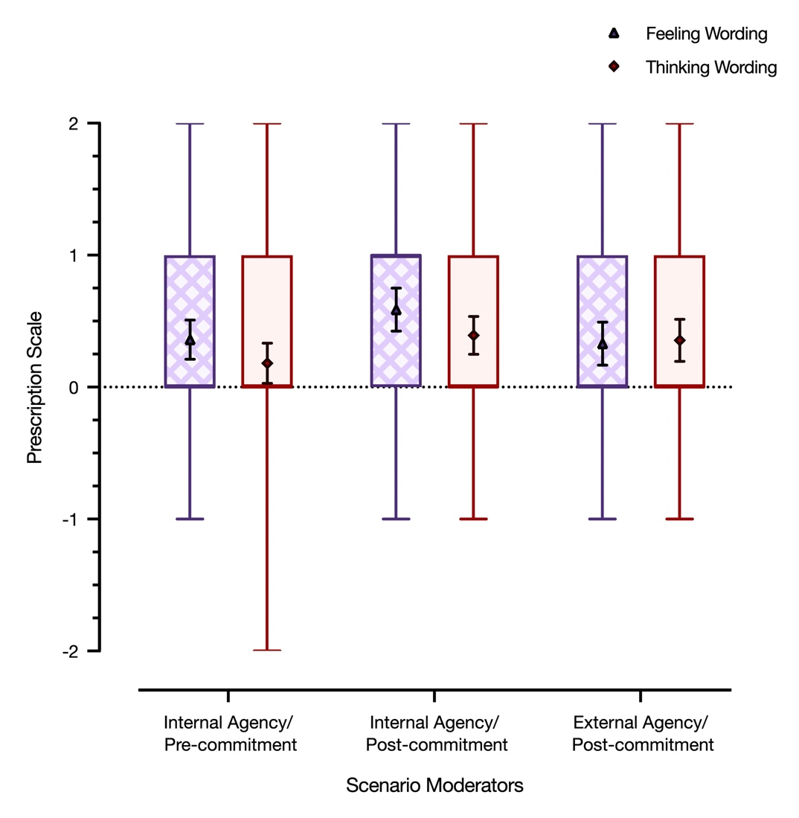
Figure 3. Study 2 mean prescriptions per scenario version and prescription wording. In each box plot, the symbol indicates the estimated mean, error bars indicate 95% confidence intervals, and the shaded box indicates the distribution of the data from the 25th to the 75th percentile.
Study 3
Method
Study 3 was similar to Study 2 but addressed the impact of estimation wording (vs. optimism/pessimism wording). We again had two wording conditions for which there was no best/ideal confound and for which there was a feeling-vs-thinking distinction. Unlike in Study 2, the condition that asked about thinking was the same as the estimation wording from Study 1 and included response options that again referred to estimations (of likelihood) rather than to optimism/pessimism. If this change is crucial, then we should see a significant effect of the wording manipulation.
Design, Participants, and Statistical Power
Study 3 had a 2(Wording: estimation/feeling) x 3(Version) x 2(Order) mixed design, with order as the only between-subject variable (in addition to the same counterbalancing was in Studies 1 and 2, which will not be discussed further). We preregistered a sample size of 180 participants. The preregistration can be found at osf.io/zq8xj. After all posted sessions were completed, the final sample size was 208 University of Iowa undergraduates (144 women, 64 men, M_{age} = 18.70, SD = 1.06). This sample size provided 99.9% power to detect a medium-small difference (d = 0.35) in prescriptions between the two wording conditions.
Prescription Measures and Counterbalancing of Measures
In the same fashion as Study 2, participants answered both prescription questions, presented on the same page, for each of the three scenarios. Half of the participants saw the Feelings prescription first followed by the Estimation prescription, and the other half saw the reverse order. Similar to Study 2, the introductory wording of the second measure was altered slightly to reduce participant confusion. For example, for the first question about the Lisa scenario, the wording of the Feeling/Estimation prescription was as follows:
Under the circumstances described in this story, how should Lisa [feel about/estimate] the likelihood of winning the award? In other words, what way of [feeling/thinking] would be advisable? In light of the situation that she is in, Lisa should [feel] _____ [about] her likelihood of winning the award.
For the second question, the wording was as follows:
You’ve told us how you think Lisa should [feel about/estimate] the likelihood of winning the award. Now we’d like to know how you think Lisa should [estimate/feel about] the likelihood of winning the award. Your answer to this question might or might not be similar to your other answer. In light of the situation that she is in, Lisa should [feel] _____ [about] her likelihood of winning the award.
The response options for the Feelings prescriptions involved pessimism/optimism terms. Specifically, they were always Extremely pessimistic, Moderately pessimistic, Realistic, Moderately optimistic, and Extremely optimistic. The response options for the Estimation prescription were always Greatly underestimate, Slightly underestimate, Accurately estimate, Slightly overestimate, and Greatly overestimate.
Results
The primary analysis was a 2(Wording: Estimation/Feeling) x 3(Version) x 2(Order) repeated measures ANOVA. There were no significant effects involving order or scenario version (all ps > .10), showing that neither the order of the prescriptions or the different scenario versions had any influence on prescriptions. The only significant effect was a main effect of prescription wording (all other ps > .17).
Akin to the results of Study 1, participants answered the prescription questions differently as a function of the wording, F(1, 204) = 205.45, p < .001, η_{p}² = .502. See Figure 4 for the result pattern. With the Feeling prescription measure (involving pessimism/optimism responses options), participants prescribed optimism, which was significantly above the midpoint of “realistic” (M = 0.34, SD = 0.48), t(207) = 10.22, p < .001, d = 1.42, 95% CI [0.27, 0.41]. However, with the Estimation prescription measure, participants prescribed underestimating the likelihood of the uncertain outcomes, which was also significantly below the midpoint of “accurately estimate” (M = -0.24, SD = 0.45), t(207) = -7.77, p < .001, d = -1.08, 95% CI [-0.31, -0.18]. Given that the previously discussed best/ideal confound was not relevant to Study 3, the similarity between the results of Study 1 and Study 3 suggest that the presence of the words optimism/pessimism in the response anchors is the key reason underlying the difference between the results found in Armor et al. (2008) and the results presented here.
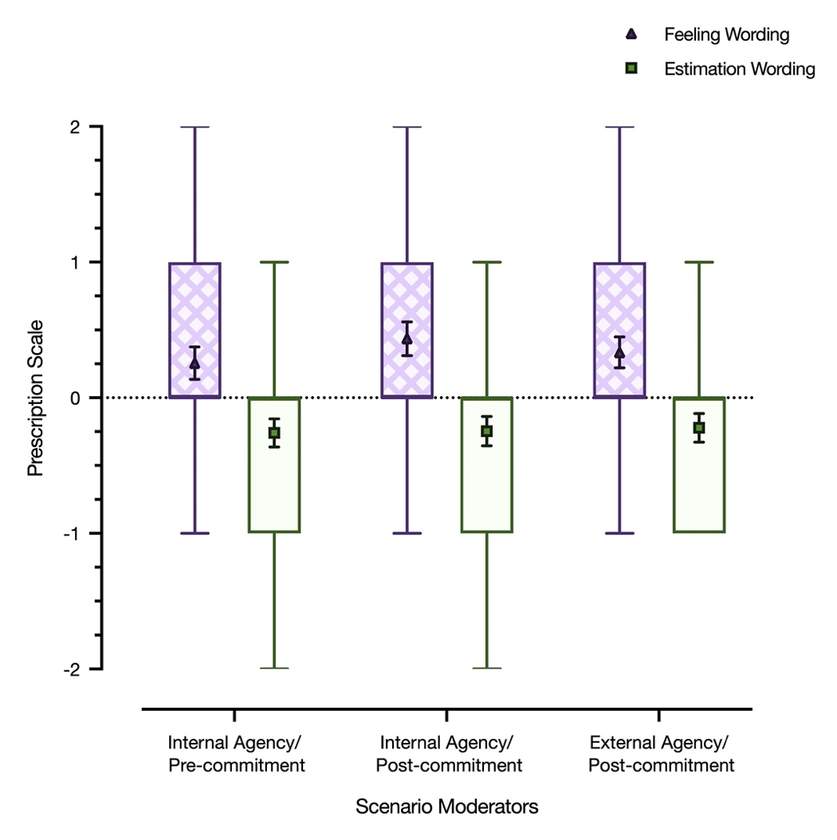
Figure 4. Study 3 mean prescriptions per scenario version and prescription wording. In each box plot, the symbol indicates the estimated mean, error bars indicate 95% confidence intervals, and the shaded box indicates the distribution of the data from the 25th to the 75th percentile. Note: The bar for Estimation Wording in the External Agency/Post-commitment condition lacks a whisker due to the distribution of the lowest quartile being equivalent to the minimum value of the scale.
In a similar fashion as Study 1, we also ran an analysis with scenario (i.e., award, surgery, investment) as the repeated variable. In a 2(Wording) x 3(Scenario) repeated measures ANOVA, the effect of wording was the same as already reported. The effect of scenario was significant, reflecting the fact that optimism was differentially prescribed across scenarios/protagonists, F(2, 408) = 18.74, p < .001, η_{p}² = .040. However, there was not a significant Wording x Scenario interaction, indicating that difference in prescribed optimism between the Feeling and Estimation prescriptions was similar across the different scenarios, F(2, 408) = 0.86, p = .424, η_{p}² = .004.
Finally, since Study 3 had a within-subjects design (as did Study 2), the results show that the same participants can and will prescribe both feeling optimistic yet underestimating the likelihood of desired outcomes. In fact, 151 out of the 208 participants prescribed optimism yet also prescribed accurate or underestimation to at least one of the three scenarios.

Table 4. Study 3 Mean Prescriptions Per Scenario, Version, and Prescription Wording
Scenarios | Prescription  Wording | Scenario Moderators |  |  | Average  (collapsed across versions)
 |  | Internal agency/  pre-commitment | Internal agency/  post-commitment | External agency/  post-commitment
Scenario 1  (Award) | Feeling Wording | 0.25 (0.82) | 0.18 (0.81) | 0.24 (0.79) | 0.22
 | Estimation Wording | -0.33 (0.69) | -0.38 (0.71) | -0.47 (0.61) | -0.39
Scenario 2  (Surgery) | Feeling Wording | 0.34 (0.95) | 0.72 (0.91) | 0.51 (0.91) | 0.52
 | Estimation Wording | -0.01 (0.73) | 0.04 (0.85) | 0.01 (0.77) | 0.01
Scenario 3  (Investment) | Feeling Wording | 0.17 (0.87) | 0.40 (0.94) | 0.26 (0.77) | 0.28
 | Estimation Wording | -0.44 (0.81) | -0.40 (0.75) | -0.21 (0.85) | -0.35
Note. Parenthetical numbers reflect standard deviations. The Feeling wording prescription went from -2 (Extremely pessimistic) to +2 (Extremely optimistic), with the midpoint labeled as "Accurate". The Estimation wording prescription scale went from -2 (Greatly underestimate) to +2 (Greatly overestimate), with the midpoint labeled as "Accurately estimate".

General Discussion
Although the findings from Armor et al. (2008) are commonly interpreted as showing that people think it is better to be optimistic than accurate or pessimistic, the present findings offer a crucial clarification and extension. In Study 1, we replicated the prescribed-optimism findings with the original prescription questions from Armor et al (2008). However, a different question wording produced quite different results—people prescribed underestimating the likelihood of the outcomes.
Studies 2 and 3 teased out which of three wording differences accounted for the dramatic change in results. An emphasis on feeling versus thinking didn’t account for the change, nor did removing potentially biasing words. Instead, the change was attributable to a switch from asking about optimism/pessimism to asking about likelihood estimations. This is broadly consistent with our notion that the term optimism holds many potential meanings, some of which are viewed favorably and might make prescriptions of optimism generally appealing.
These findings reveal that even as people generally prescribe being optimistic, feeling optimistic, or even thinking optimistically, they don’t generally prescribe overestimating the likelihood of desirable outcomes. Does this mean that people prescribe overoptimism? By overoptimism, we mean prescribing a level of optimism that is greater than what objective standards warrant (Windschitl & Stuart, 2015). The answer might be both yes and no. When people are asked for prescriptions using the familiar language of pessimism, accuracy, and optimism—which is the original language from Armor et al. (2008)—the fact that people tended to pick a response that was above “accurate” arguably fits the definition of overoptimism. Yet, when asked for prescriptions in reference to the likelihood estimation, the results do not suggest people endorse overoptimism.
This is not a trivial clarification. Prescribing optimism does not necessarily suggest an endorsement of self-deception or wishful thinking, but prescribing overoptimism—whether by favoring optimism over accuracy or by favoring an overestimation of the likelihood of a desired event—seems almost tantamount to such endorsements (Von Hippel & Trivers, 2011; Windschitl, Smith, Rose, & Krizan, 2010).
Curiously, participants’ prescriptions about likelihood estimates in our studies were not balanced on “accurately estimate”—they were significantly below the midpoint of the scale (Studies 1 and 3). This could also be considered a form of self-deception, just in a cautious direction. A full explication of why people would endorse this pessimistic position (even when they would favor “optimism” on a pessimism-accuracy-optimism scale) is beyond the scope of this paper, but it could be that participants recognized that the protagonists of each scenario had little-to-no control over the outcome, thus reducing optimistic outlooks (e.g., Shepperd, Falkenstein, & Sweeny, 2020). This might reflect that people perceive benefits to being defensively pessimistic and/or bracing (Carroll et al., 2006; Norem & Cantor, 1986; see also Weber, 1994). Future research could further explore these connections by using scenarios that manipulated how much control the protagonist has over the outcome.
Future research could also delve further into the generalizability of our findings. Although optimism is sometimes said to be a universal feature of human cognition (Fischer & Chalmers, 2008; Sharot, Korn, & Dolan, 2011), there is evidence for differences across Eastern and Western cultures in the prevalence and degree of optimism (Chang & Asakawa, 2003; Heine & Hamamura, 2007; Rose, Endo, Windschitl, & Suls, 2008), as well as evidence for gender differences (Helweg-Larsen, Harding, & Klein, 2011). There is also substantial variability in optimism as a personality trait (Carver et al., 2010). Although our findings were robust against gender effects, our studies were conducted in the United States and without personality measures, limiting our knowledge of how our findings about prescriptions might generalize across cultures or other dimensions.
In conclusion, our work provides another example of how, when studying people’s reports about constructs that may have vague, malleable, or complex lay interpretations, adding new measures, perhaps of more specific components, can be crucial (e.g., Barrett, 2006; Lucas, 2018; Moore & Schatz, 2017). We have suggested that lay interpretations of “optimism” and “pessimism” are vague and malleable, and various associations people have with the terms may underly people’s tendency to favor an endorsement of optimism. Using the scenarios of Armor et al. (2008) but with new measures, we showed that although people favored prescriptions of “optimism,” they also prescribed likelihood estimates that were essentially pessimistic. Interpreting people’s prescriptions of optimism is not straightforward.

References
Armor, D. A., Massey, C., & Sackett, A. M. (2008). Prescribed optimism: Is it right to be wrong
about the future?. Psychological Science, 19, 329-331. https://doi.org/10.1111/j.1467-9280.2008.02089.x
Armor, D. A., & Taylor, S. E. (2002). When predictions fail: The dilemma of unrealistic
optimism. In T. Gilovich, D. Griffin, & D. Kahneman (Eds.), Heuristics and Biases: The Psychology of Intuitive Judgment (p. 334–347). Cambridge University Press. https://doi.org/10.1017/CBO9780511808098.021
Barrett, L. F. (2006). Are emotions natural kinds?. Perspectives on Psychological Science, 1,
28-58. https://doi.org/10.1111/j.1745-6916.2006.00003.x
Carroll, P., Sweeny, K., & Shepperd, J. A. (2006). Forsaking optimism. Review of General
Psychology, 10, 56-73. https://doi.org/10.1037/1089-2680.10.1.56
Carver, C. S., Scheier, M. F., & Segerstrom, S. C. (2010). Optimism. Clinical Psychology
Review, 30, 879-889. https://doi.org/10.1016/j.cpr.2010.01.006
Chang, E. C., & Asakawa, K. (2003). Cultural variations on optimistic and pessimistic bias for
self versus a sibling: Is there evidence for self-enhancement in the West and for self-criticism in the East when the referent group is specified? Journal of Personality and Social Psychology, 84, 569–581. https://doi.org/10.1037/0022-3514.84.3.569
Chang, W., Chen, E., Mellers, B., & Tetlock, P. (2016). Developing expert political judgment:
The impact of training and practice on judgmental accuracy in geopolitical forecasting tournaments. Judgment and Decision Making, 11(5), 509-526.
Fischer, R., & Chalmers, A. (2008). Is optimism universal? A meta-analytical investigation of
optimism levels across 22 nations. Personality and Individual Differences, 45, 378-382. https://doi.org/10.1016/j.paid.2008.05.008
Gasper, K., Lozinski, R. H., & LeBeau, L. S. (2009). If you plan, then you can: How reflection
helps defensive pessimists pursue their goals. Motivation and Emotion, 33, 203–216. https://doi.org/10.1007/s11031-009-9125-5
Hazlett, A., Molden, D. C., & Sackett, A. M. (2011). Hoping for the best or preparing for the
worst? Regulatory focus and preferences for optimism and pessimism in predicting personal outcomes. Social Cognition, 29, 74-96. https://doi.org/10.1521/ soco.2011.29.1.74
Heine, S. J., & Hamamura, T. (2007). In search of East Asian self-enhancement. Personality and
Social Psychology Review, 11, 4-27. https://doi.org/10.1177/1088868306294587
Helweg-Larsen, M., Harding, H. G., & Klein, W. M. (2011). Will I divorce or have a happy
marriage?: Gender differences in comparative optimism and estimation of personal chances among US college students. Basic and Applied Social Psychology, 33, 157-166. https://doi.org/10.1080/01973533.2011.568874
Helweg-Larsen, M., Sadeghian, P., & Webb, M. S. (2002). The stigma of being pessimistically
biased. Journal of Social and Clinical Psychology, 21, 92-107. https://doi.org/10.1521/jscp.21.1.92.22405
Hoorens, V., Van Damme, C., Helweg-Larsen, M., & Sedikides, C. (2017). The hubris
hypothesis: The downside of comparative optimism displays. Consciousness and Cognition, 50, 45-55. https://doi.org/10.1016/j.concog.2016.07.003
Klaaren, K. J., Hodges, S. D., & Wilson, T. D. (1994). The role of affective expectations in
subjective experience and decision-making. Social Cognition, 12, 77–101. https://doi.org/10.1521/soco.1994.12.2.77
Leedham, B., Meyerowitz, B. E., Muirhead, J., & Frist, W. H. (1995). Positive expectations
predict health after heart transplantation. Health Psychology, 14, 74–79. https://doi.org/10.1037/0278-6133.14.1.74
Lucas, R. E. (2018). Reevaluating the strengths and weaknesses of self-report measures of
subjective well-being. In E. Diener, S. Oishi, & L. Tay (Eds.), Handbook of Well-Being. Salt Lake City, UT: DEFPublishers.
Moore, D. A., & Schatz, D. (2017). The three faces of overconfidence. Social and Personality
Psychology Compass, 11, e12331. https://doi.org/10.1111/spc3.12331
Moore, D. A., Swift, S. A., Minster, A., Mellers, B., Ungar, L., Tetlock, P., ... & Tenney, E. R.
(2017). Confidence calibration in a multiyear geopolitical forecasting competition. Management Science, 63, 3552-3565. https://doi.org/10.1287/mnsc.2016.2525
Morewedge, C. K. (In press). Utility: Anticipated, Experienced, and Remembered. In G. Keren
and G. Wu (Eds.), Blackwell Handbook of Judgment and Decision Making, 2nd Edition. Malden, MA: Blackwell Press
Norem, J. K., & Cantor, N. (1986). Defensive pessimism: Harnessing anxiety as motivation.
Journal of Personality and Social Psychology, 51, 1208-1217.
Open Science Collaboration. (2015). Estimating the reproducibility of psychological
science. Science, 349(6251). DOI: 10.1126/science.aac4716
Peterson, C. (2000). The future of optimism. American Psychologist, 55(1), 44-55.
Rose, J. P., Endo, Y., Windschitl, P. D., & Suls, J. (2008). Cultural differences in unrealistic
optimism and pessimism: The role of egocentrism and direct versus indirect comparison measures. Personality and Social Psychology Bulletin, 34, 1236-1248. https://doi.org/10.1177/0146167208319764
Scheier, M. F., & Carver, C. S. (1993). On the power of positive thinking: The benefits of being
optimistic. Current Directions in Psychological Science, 2(1), 26-30.
Seligman, M. E. (2006). Learned optimism: How to change your mind and your life. New York,
New York: Vintage Books.
Sharot, T., Korn, C. W., & Dolan, R. J. (2011). How unrealistic optimism is maintained in the
face of reality. Nature Neuroscience, 14, 1475-1479. https://doi.org/10.1038/nn.2949
Shepperd, J. A., Falkenstein, A., & Sweeny, K. (2018). Fluctuations in future outlooks:
Unrealistic optimism and pessimism in outcome predictions. In G. Oettingen, A. T. Sevincer, & P. Gollwitzer (Eds.), The Psychology of Thinking about the Future (p. 231–249). The Guilford Press.
Shepperd, J. A., Waters, E. A., Weinstein, N. D., & Klein, W. M. (2015). A primer on unrealistic
optimism. Current Directions in Psychological Science, 24, 232-237. https://doi.org/10.1177/0963721414568341
Soll, J. B., Milkman, K. L., & Payne, J. W. (2015). A user’s guide to debiasing. The Wiley
Blackwell Handbook of Judgment and Decision Making, 2, 924-951.
Sweeny, K., & Krizan, Z. (2013). Sobering up: A quantitative review of temporal declines in
expectations. Psychological Bulletin, 139(3), 702-724.
Tenney, E. R., Logg, J. M., & Moore, D. A. (2015). (Too) optimistic about optimism: The belief
that optimism improves performance. Journal of Personality and Social Psychology, 108, 377–399. https://doi.org/10.1037/pspa0000018
Tetlock, P. E., & Gardner, D. (2015). Superforecasting: The Art and Science of Prediction. New
York, New York: Crown Publishers.
Von Hippel, W., & Trivers, R. (2011). The evolution and psychology of self-deception.
Behavioral and Brain Sciences, 34(1), 1-16.
Weber, E. U. (1994). From subjective probabilities to decision weights: The effect of asymmetric
loss functions on the evaluation of uncertain outcomes and events. Psychological Bulletin, 115, 228–242. https://doi.org/10.1037/0033-2909.115.2.228
Willard, G., & Gramzow, R. H. (2009). Beyond oversights, lies, and pies in the sky:
Exaggeration as goal projection. Personality and Social Psychology Bulletin, 35, 477-492. https://doi.org/10.1177/0146167208329631
Windschitl, P. D., & O’Rourke, J. L. (2015). Optimism biases: types and causes. Blackwell
Handbook of Judgment and Decision Making, Wiley, New York, 431-455. https://doi.org/10.1002/9781118468333.ch15
Windschitl, P. D., Smith, A. R., Rose, J. P., & Krizan, Z. (2010). The desirability bias in
predictions: Going optimistic without leaving realism. Organizational Behavior and Human Decision Processes, 111, 33-47. https://doi.org/10.1016/j.obhdp.2009.08.003
Zhang, Y., & Fishbach, A. (2010). Counteracting obstacles with optimistic predictions. Journal
of Experimental Psychology: General, 139, 16–31. https://doi.org/10.1037/a0018143

Do People Prescribe (Over)Optimism?
Author Contributions

P.D. Windschitl conceived the idea for the study. All authors contributed to study design and development. J.E. Miller and I. Park prepared materials for testing. J.E. Miller analyzed the data. J.E. Miller and P.D. Windschitl wrote the manuscript. All authors contributed to editing and approved the final version for submission. We thank Ireland Mahoney for her contributions in organizing and running participant sessions.

The data presented in Study 2 was collected after the data in Study 3, but the two studies were created and developed at the same time.
It is unlikely the wording effect is attributable to response pressures created by the within-subject design, because Study 2 also used a within-subject design.

